**Web Hackathon**

**Group Members:**

Nakhwa Arman Anis- 45

Shirgaonkar Ved Sagar- 69

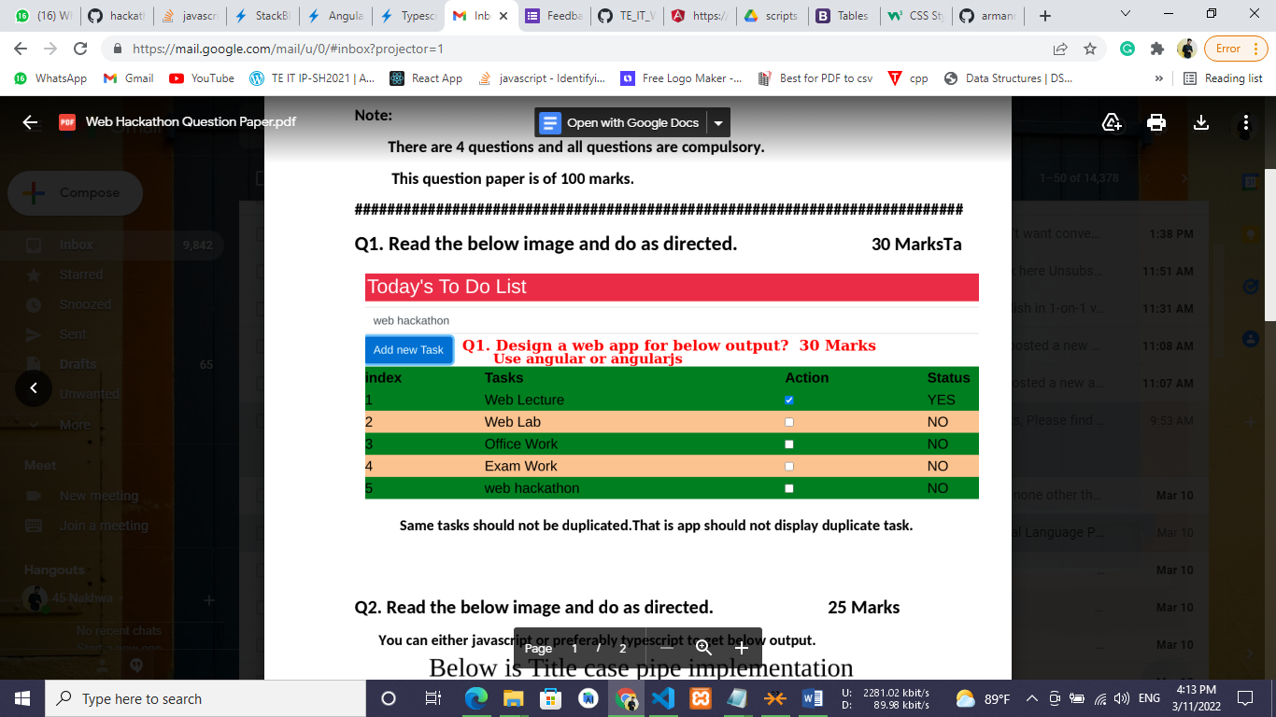**Ans->**

**Source code:** [Click Here](https://github.com/armannakhwa/web-hackathon/tree/main/Q1)

**Output:** 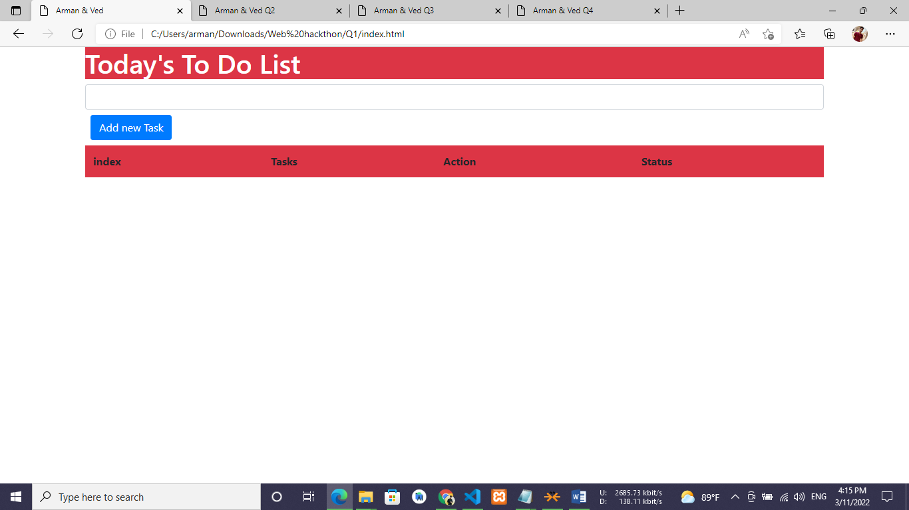

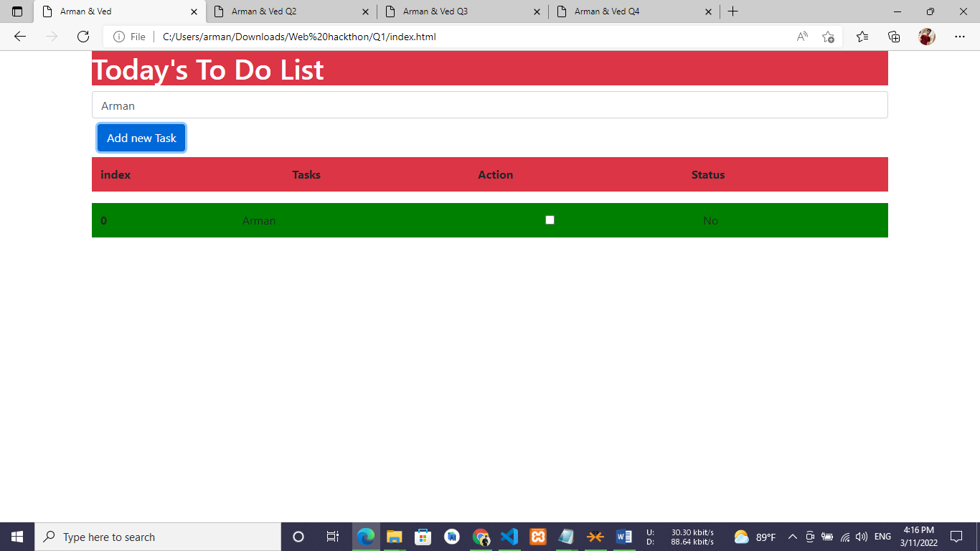

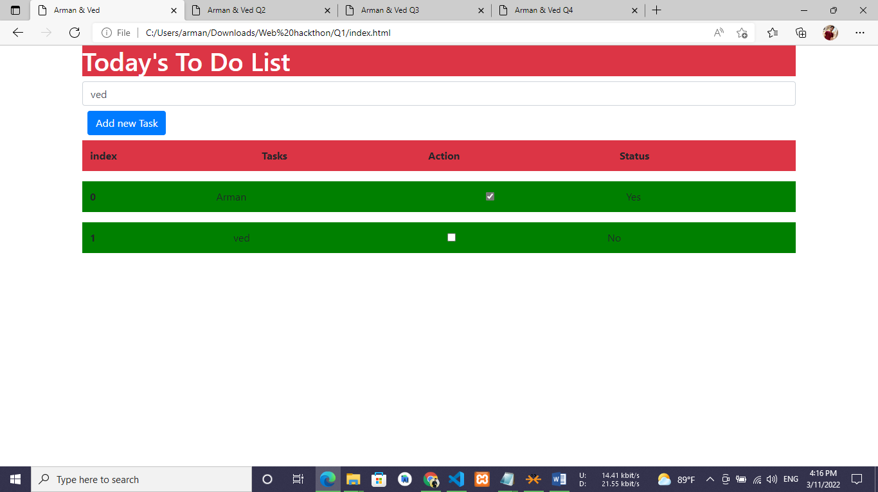

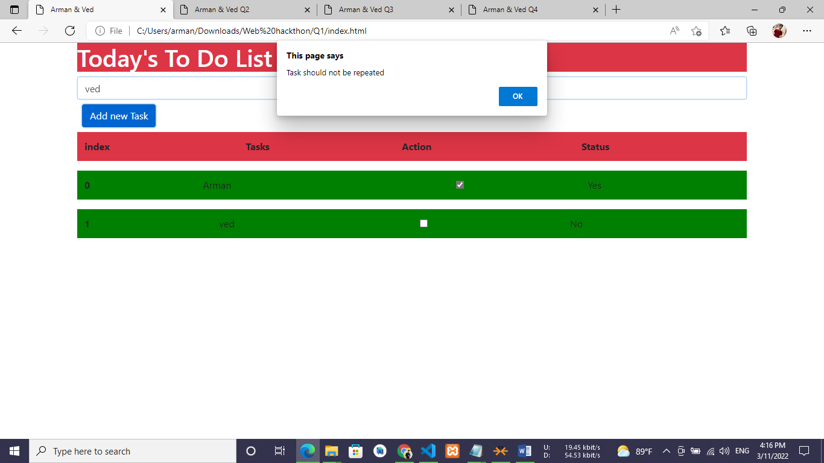

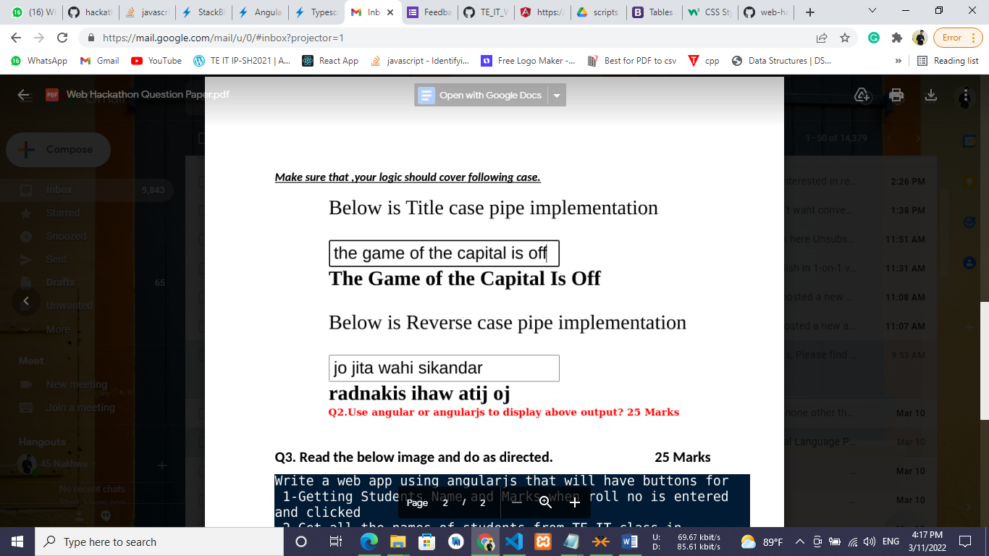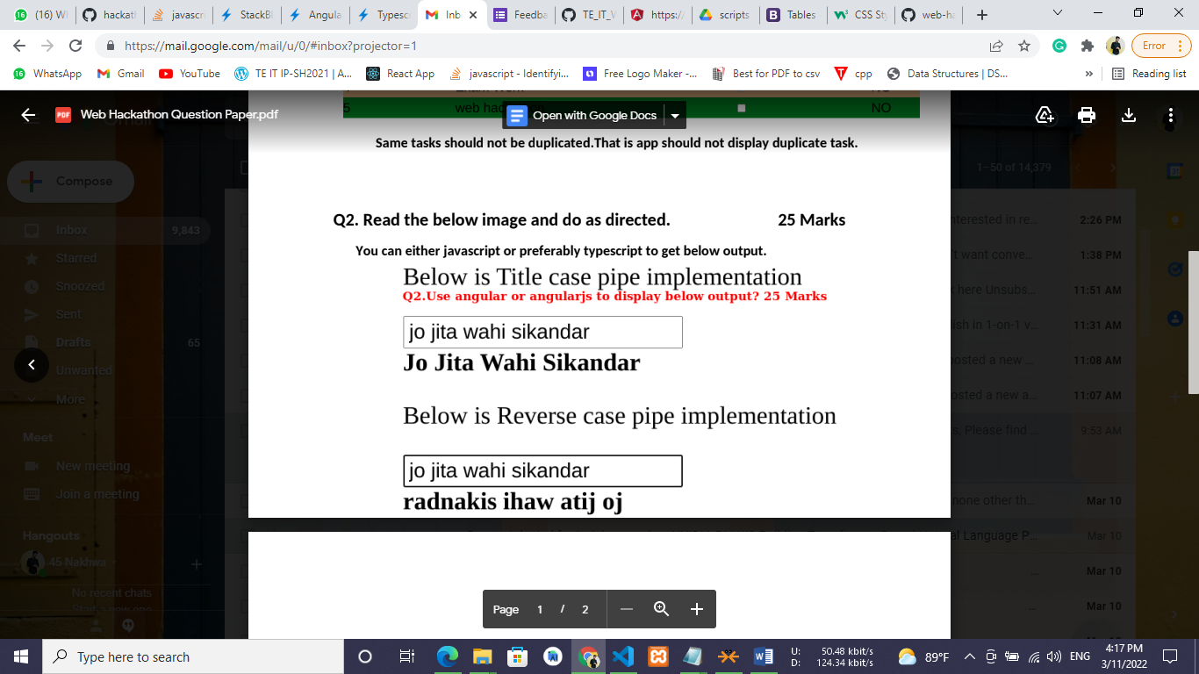

**Ans->**

**Source code:** [Click Here](https://github.com/armannakhwa/web-hackathon/tree/main/Q2)

**Output:** 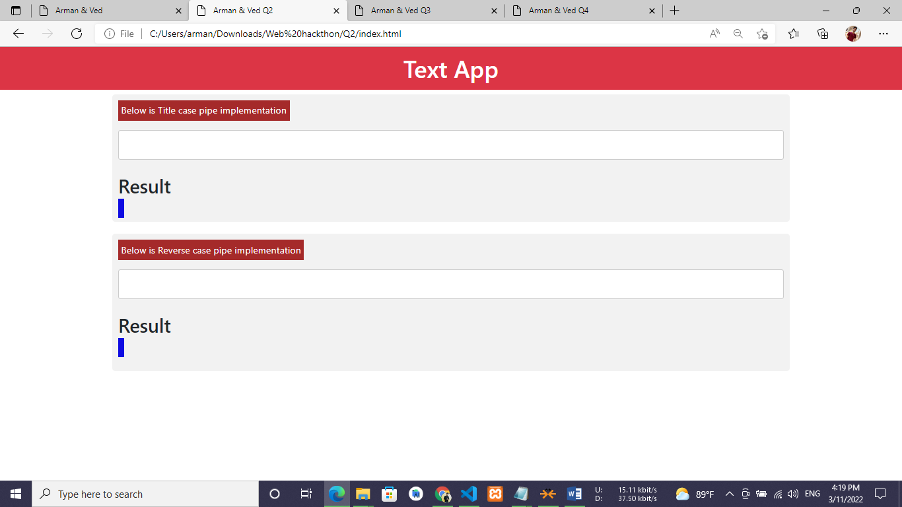

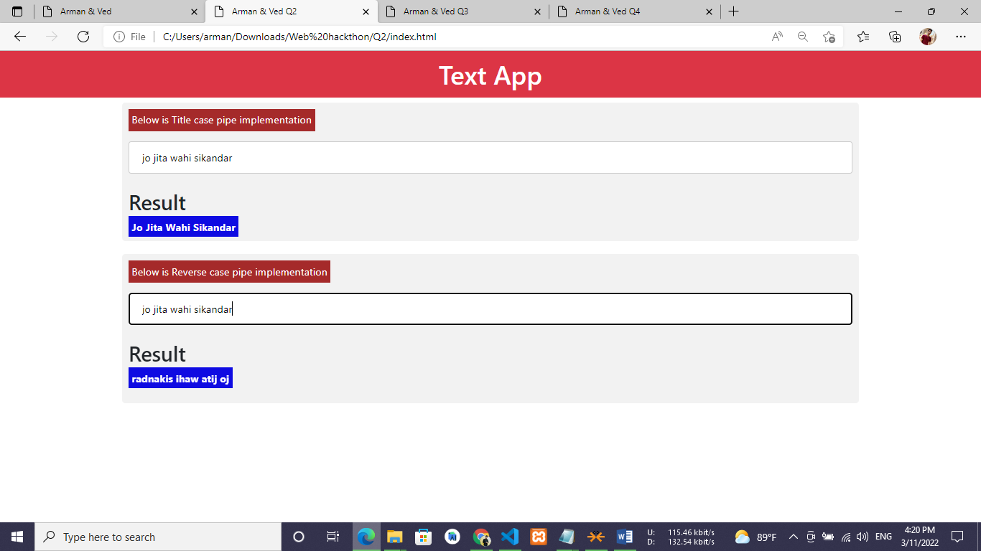

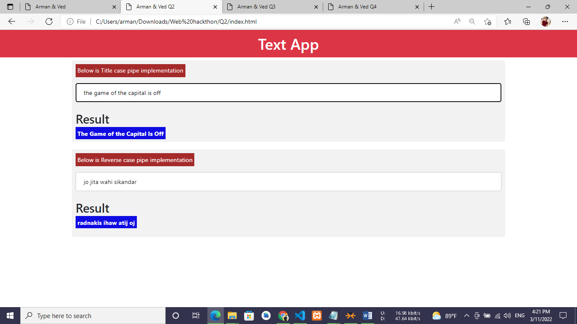

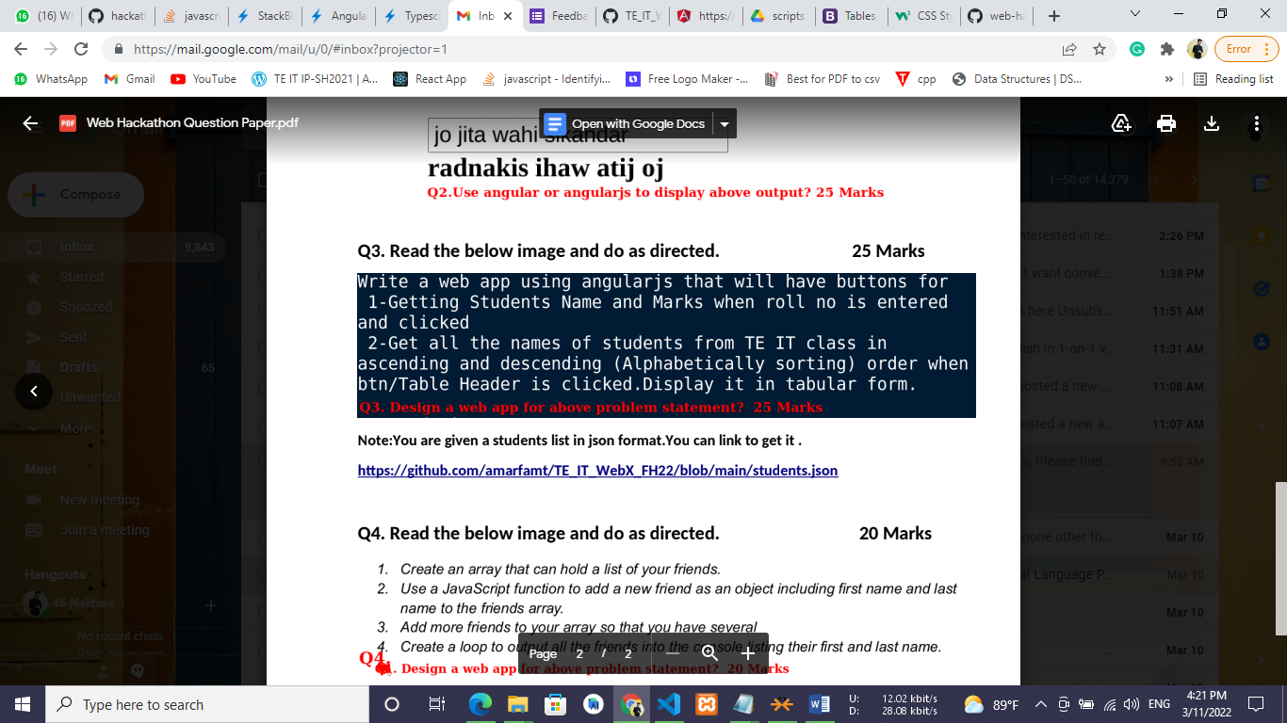

**Source code:** [Click Here](https://github.com/armannakhwa/web-hackathon/tree/main/Q3)

**Output:** 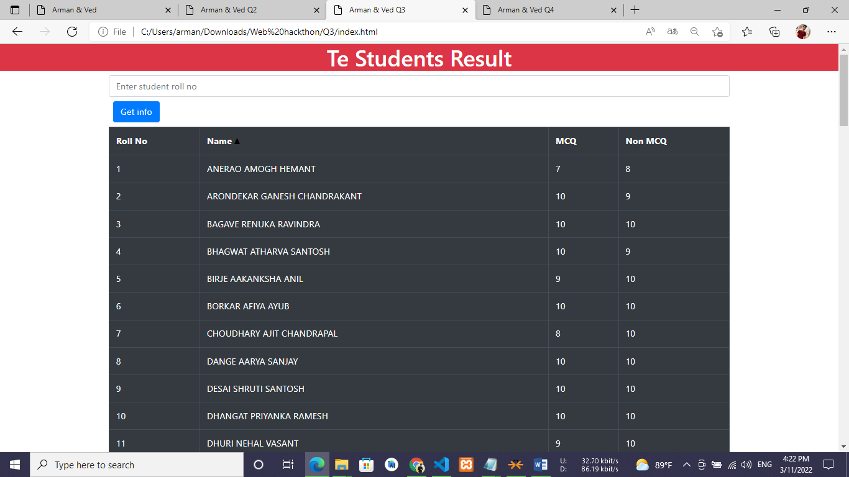

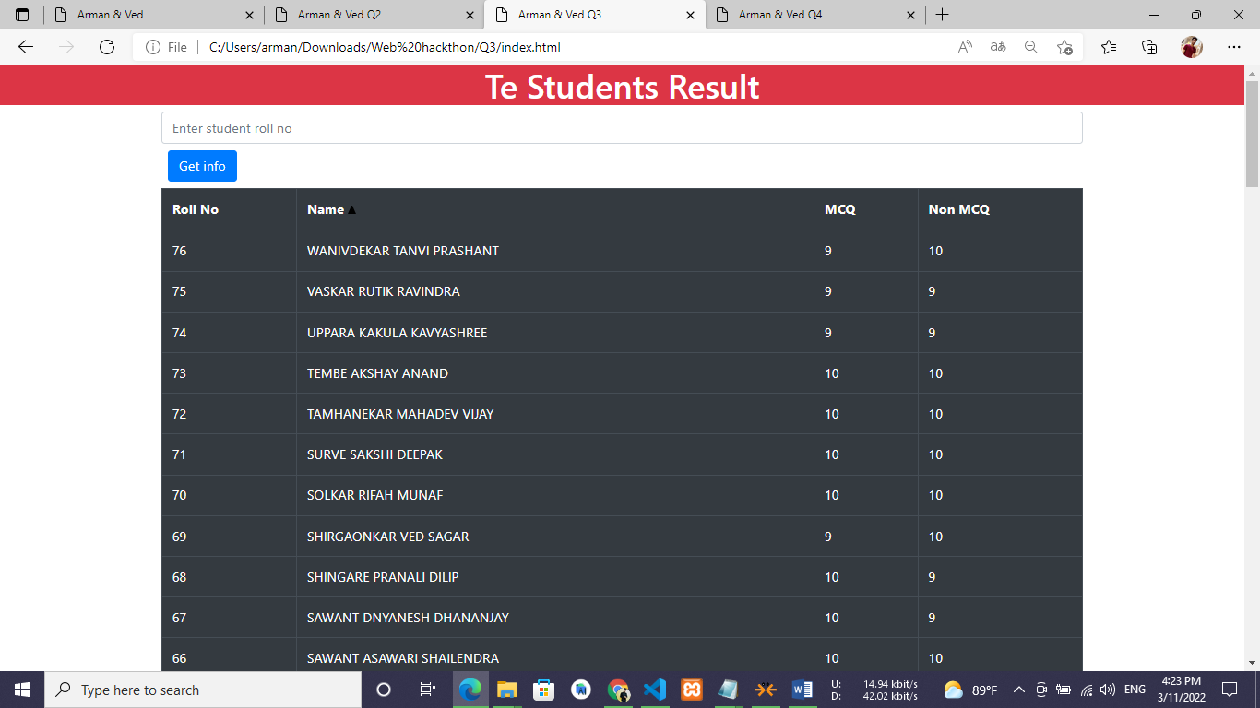

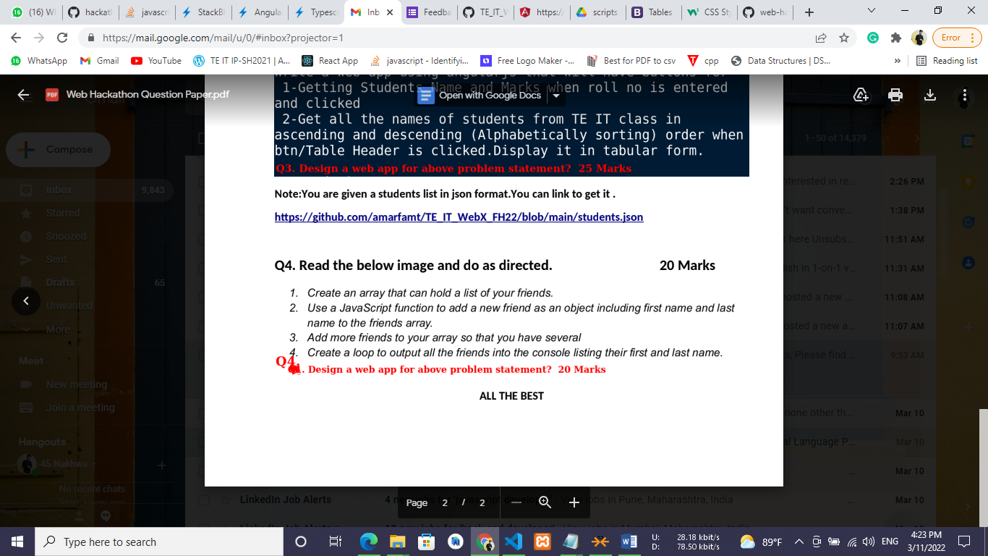**Source code:** [Click Here](https://github.com/armannakhwa/web-hackathon/tree/main/Q4)

**Output:**

